# DBS301 Lab 6 *–* Muhammad Ahmed – 126330166 – Sec: D

# Prof. Nebojsa Conkic

1.

select last_name, job_id, department_id

from employees

where department_id = (select department_id from employees

where (last_name like '%Zlotkey%') )

and last_name not like '%Zlotkey%';

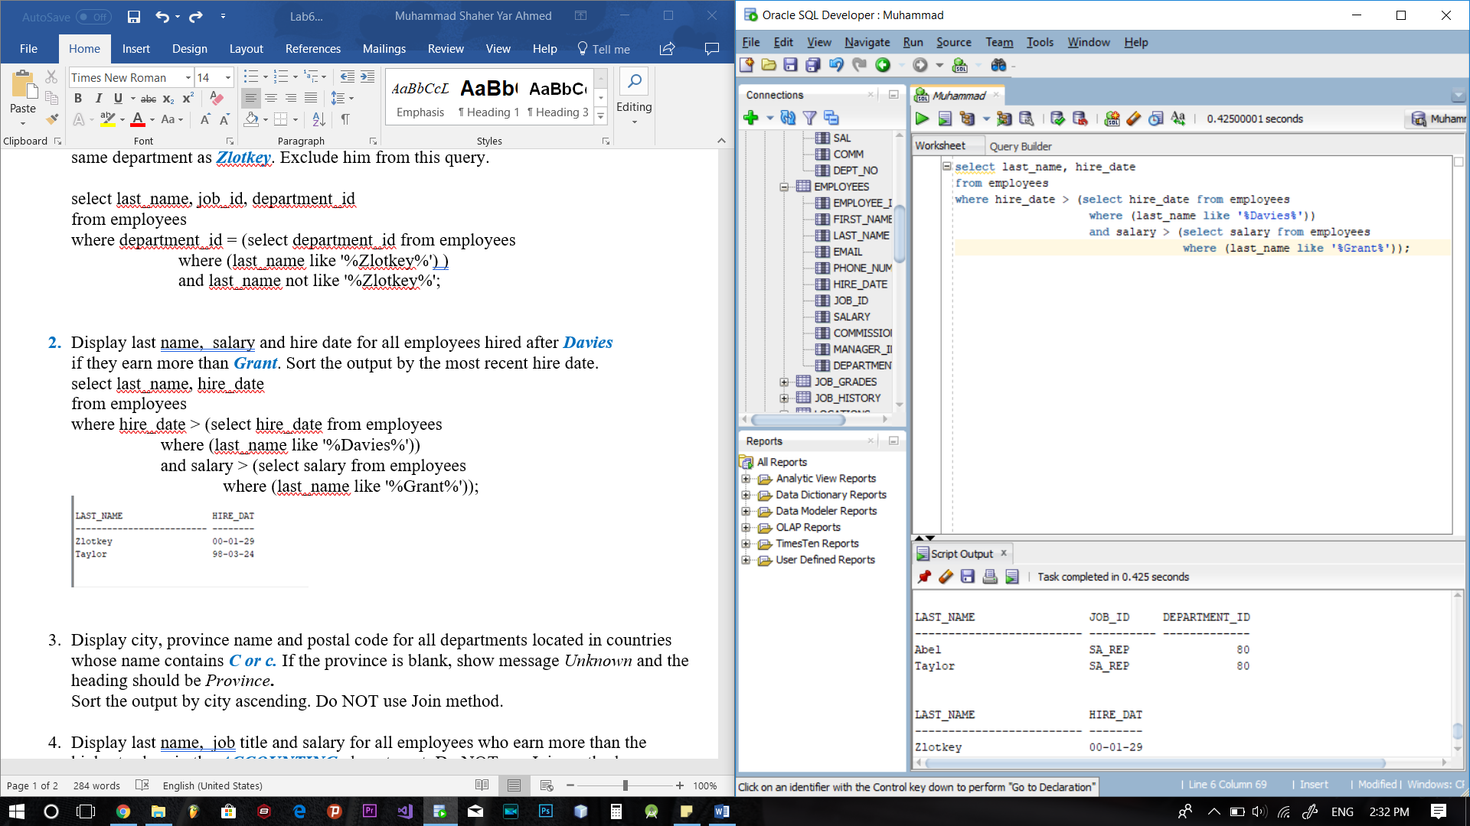

2.

select last_name, hire_date

from employees

where hire_date > (select hire_date from employees.

where (last_name like '%Davies%'))

and salary > (select salary from employees

where (last_name like '%Grant%'));

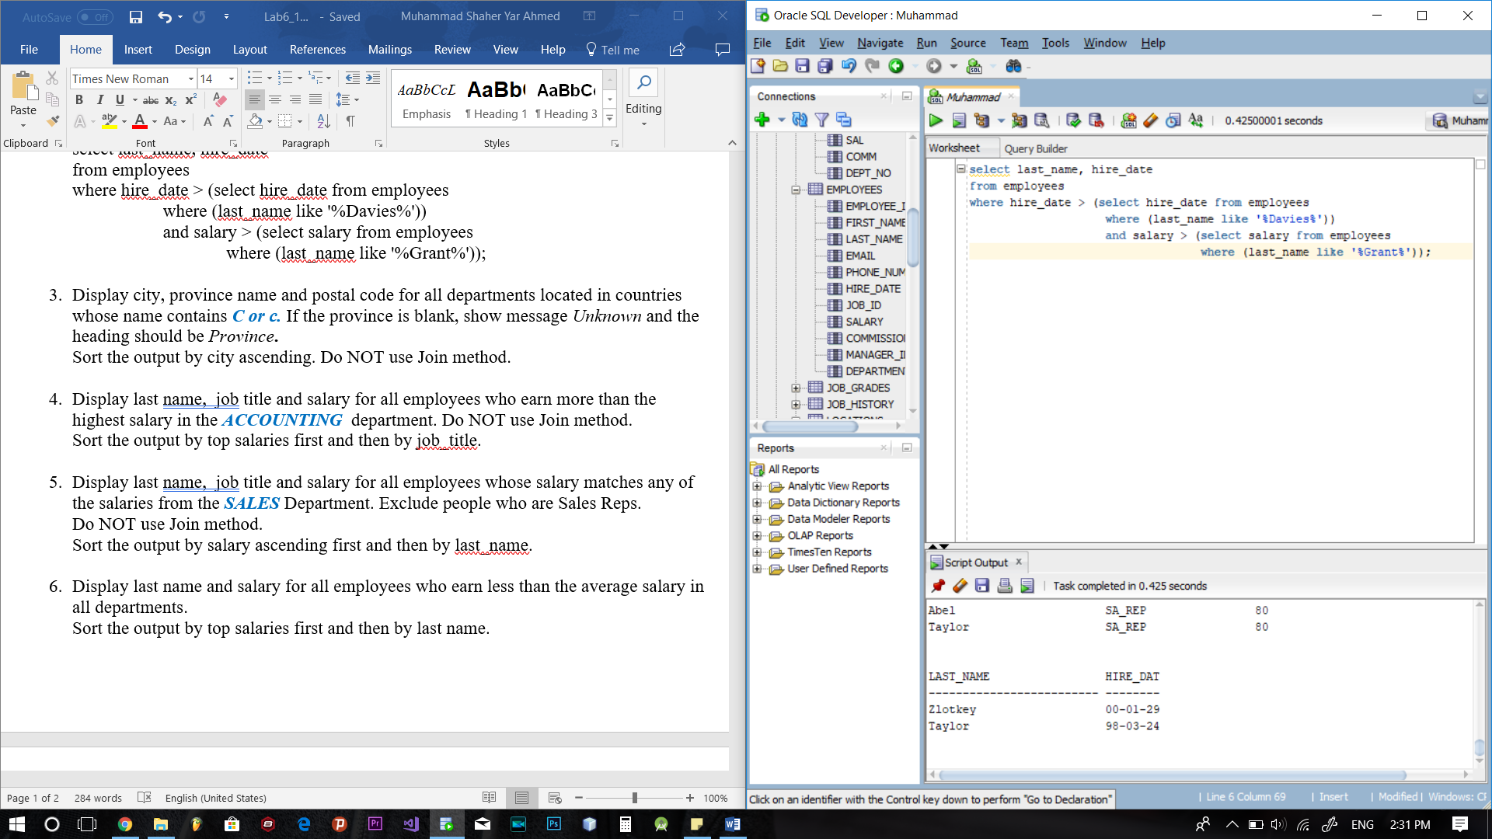

3.

select city, nvl(state_province,'Unknown') "Province", postal_code

from locations

where country_id like 'C%' or country_id like 'c%'

order by city;

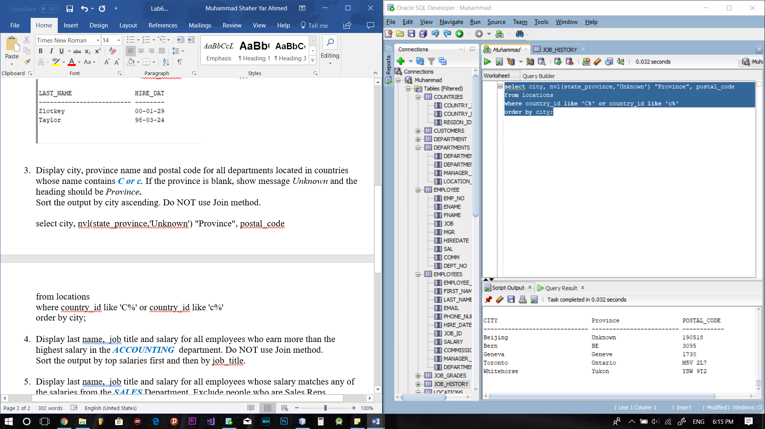

4.

select last_name, job_id, salary

from employees

where salary > (select max(salary) from employees

where department_id in (select department_id

from departments

where department_name = 'Accounting'

))

order by salary desc, job_id;

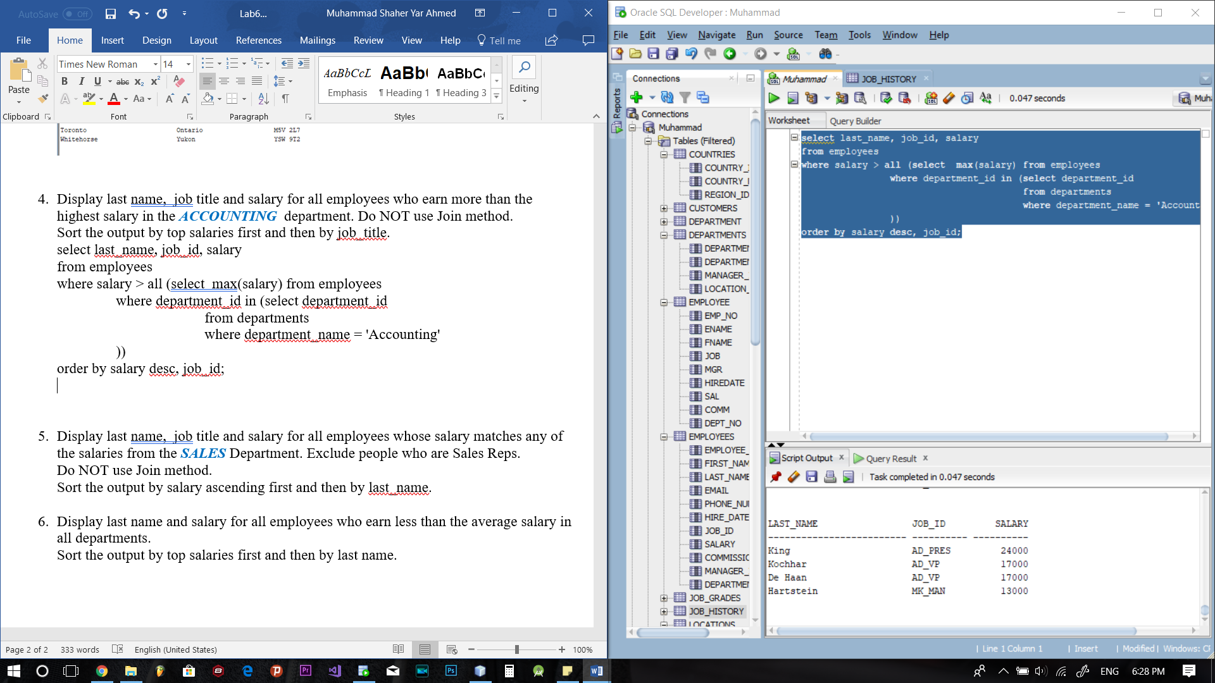

5.

select last_name, job_id, salary

from employees

where salary = (select salary from employees

where department_id in (select department_id

from departments

where department_name = 'Sales'

)and job_id not like 'SA_REP')

order by salary, last_name;

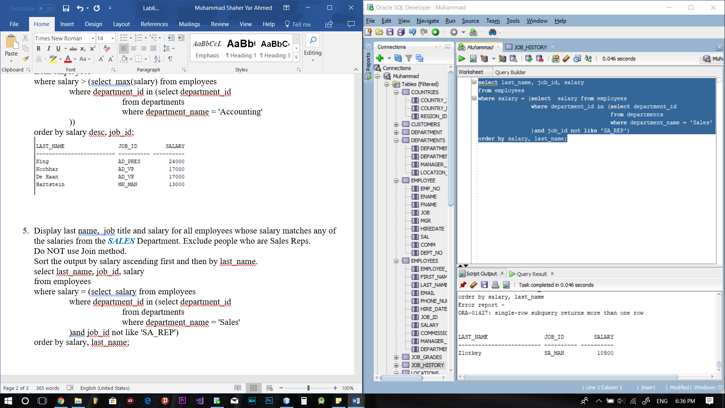

6.

Sort the output by top salaries first and then by last name.

select last_name, salary

from employees

where salary < all(select avg(salary) from employees

)

order by salary desc, last_name;

